PROJECT FINAL REPORT

DIGITAL MARKETING (NAAN MUDHALVAN)

# TITTLE: CREATING A SPONSORED POST ON INSTAGRAM-SOCIAL ADS

**NAAN MUDHALVAN GROUP ID: NM2023TMID03600**

# TEAM MEMBERS:

# 810020106310 – Rishi Kumar

# 810020106311 – Amrish

# 810020106314 – Vikram Balaji

# 810020106315 – Senthil Kumar

**INTRODUCTION:**

A sponsored Instagram post is a popular form of advertising on the social media platform, Instagram. It involves a collaboration between a business or brand and an influencer or content creator to promote a product, service, or event. These posts are typically marked with a clear disclosure, such as "Sponsored" or "Paid partnership with [Brand]," to inform the audience that the content is a paid promotion.

These posts can take various forms, including photos, videos, Stories, and carousel posts, and they are designed to seamlessly integrate the promotional content into the influencer's feed. Overall, sponsored Instagram posts have revolutionized digital advertising by providing a more personal and engaging approach, and they have become an essential part of many marketing strategies in today's digital landscape.

# ABSTRACT:

This abstract provides an overview of the topic "Creating a Sponsored Post on Instagram

- Social Ads." Sponsored posts on Instagram have emerged as a powerful tool in the realm of digital marketing, enabling businesses and brands to leverage the influence and reach of Instagram users to promote their products and services. This study explores the key elements involved in crafting a successful sponsored post on Instagram. It delves into the strategies and tactics that advertisers and influencers use to engage audiences, build trust, and effectively convey their marketing messages.

Additionally, it examines the technical aspects of creating and running these social ads on Instagram, including ad formats, targeting options, and campaign optimization. The abstract highlights the significance of Instagram as a platform for visual marketing and

underscores the impact of sponsored posts on contemporary digital advertising. This research provides insights into the evolving landscape of social media marketing and serves as a valuable resource for advertisers and influencers looking to harness the potential of Instagram's sponsored posts.

# IMPORTANCE AND BENEFITS OF SPONSORED POSTS IN INSTAGRAM:

Sponsored posts on Instagram allow businesses to tap into the vast user base of the platform, exposing their products or services to a broad and diverse audience. When reputable influencers endorse a product or service, it can significantly impact consumer trust and decision-making, making sponsored posts an effective way to build credibility.

Instagram is a highly engaging platform, and sponsored posts can generate likes, comments, and shares, creating a buzz around a brand or product. Instagram offers advanced targeting options, allowing businesses to reach specific demographics, interests, and behaviours ensuring that their message is seen by the right audience.

Instagram is a visual platform, making it ideal for showcasing products and services through high-quality images and videos. Instagram's insights provide valuable data on post performance, helping businesses fine-tune their marketing strategies.

Sponsored posts boost brand visibility, ensuring that more people recognize and remember a brand. They can generate leads, sign-ups, or inquiries, which can be crucial for businesses in capturing potential customers' information. By driving targeted traffic and conversion, sponsored posts can directly lead to increased sales and revenue.

When executed effectively, sponsored posts can maintain an authentic feel, as influencers often tailor content to resonate with their audience. Collaborations with influencers can result in user-generated content that businesses can leverage for future marketing efforts.

Sponsored Instagram posts complement other marketing strategies, contributing to a well- rounded approach to reaching customers.

# PROJECT IMPLEMENTATION:

## BRAND NAME:

Floramed

## CATEGORY:

Pregnancy tonic

## TARGET AUDIENCE:

Women, Expecting Mothers, Women Planning to Conceive ,Health-Conscious Individuals , Natural and Organic Product Enthusiasts, Women with Specific Health Conditions, Healthcare Professionals.

## EMAIL:

[Floramed004@gmail.com](mailto:Floramed004@gmail.com)

## BUSINESS PAGE:

[https://instagram.com/floramed.io?igshid=OGQ5ZDc2ODk2ZA==](https://instagram.com/floramed.io?igshid=OGQ5ZDc2ODk2ZA%3D%3D)

# BRAND LOGO:

**"**The brand logo designed for Floramed Pregnancy Tonic beautifully encapsulates the essence of maternal well-being and natural nourishment, reflecting the product's commitment to supporting expecting mothers on their pregnancy journey**."**



# STEPS INVOLVED IN CREATING SPONSORED POST IN INSTAGRAM:

**STEP 1:**

Creating an Instagram account.

# STEP 2:

Make sure to create a business account in Instagram page.

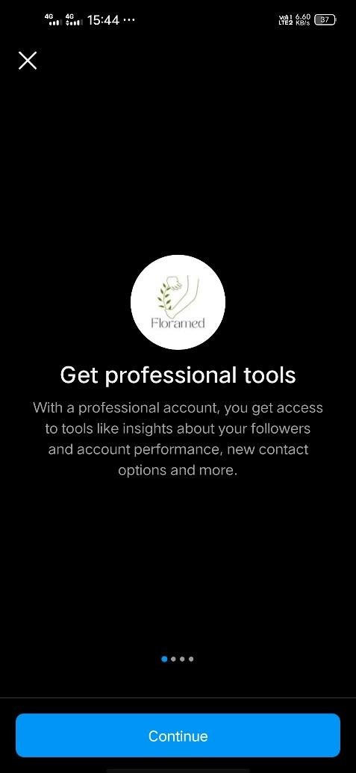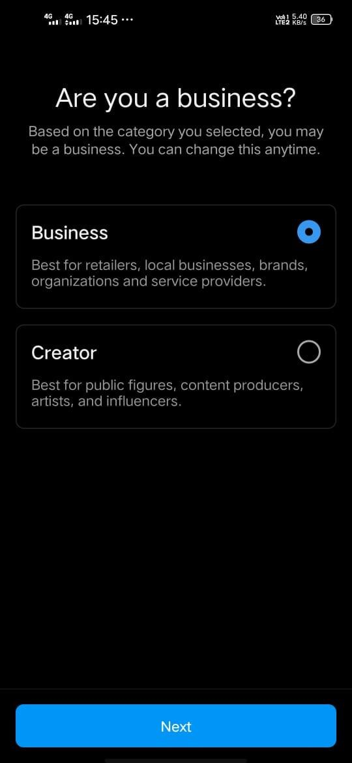

# STEP 3:

**Define Your Target Audience**

Specify the age range and gender of the audience you want to target. This is essential to make sure your ad is relevant to the people who see it.

Facebook Ads Manager (which is used to create Instagram ads) provides extensive targeting options. You can select interests, behaviors, and demographics that align with your target audience.

You can also choose to target or exclude people who have a specific connection to your Facebook Page, app, or event. This can be useful for reaching people who are already familiar with your brand. Once you've defined your target audience, you can save it for future use if you plan to run multiple campaigns with the same or similar audience criteria.

# STEP 4:

Please create the contact information section for the Instagram post to ensure our audience can easily reach us for inquiries and engagement.

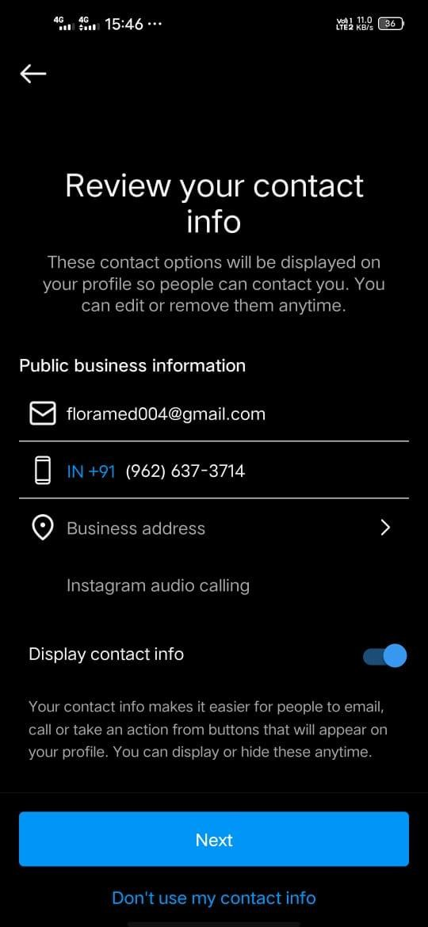

# STEPS 5:

The page has been successfully created for our Instagram account, offering a new platform for us to engage with our audience and share our content.

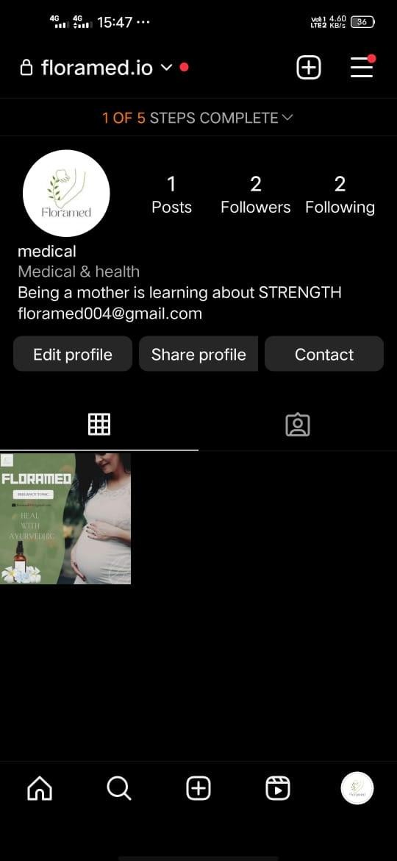

# ADVANTAGES OF CREATING A SPONSORED POST IN INSTAGRAM:

**Increased Visibility:** Sponsored posts allow you to reach a larger and more targeted audience, increasing brand exposure and awareness.

**Precise Targeting:** Instagram's ad platform offers advanced targeting options, enabling you to reach specific demographics, interests, and behaviors, ensuring your content is seen by the right audience.

**Enhanced Engagement:** Sponsored posts often receive higher engagement rates compared to organic content, as they are promoted to users who are more likely to be interested in your offerings.

**Credibility and Trust:** Collaboration with influencers can build trust and credibility for your brand, as their endorsement can be seen as a personal recommendation to their followers.

**Actionable Insights**: Instagram provides in-depth analytics, allowing you to track performance and gather valuable data on your audience's behavior and preferences.

**Call-to-Action (CTA):** You can include interactive elements like "Shop Now," "Learn More," or "Contact Us" buttons, making it easy for users to take action after viewing your post.

**Product Showcase**: Instagram's visual nature is ideal for showcasing products and services, helping users see your offerings in action.

**Storytelling:** Sponsored posts can be used to tell a compelling story about your brand or product, helping to create an emotional connection with your audience.

**Boosted Website Traffic:** You can drive traffic to your website by including links in your sponsored posts, leading to potential sales and conversions.

**Adaptability:** Sponsored posts can be tailored to various objectives, whether it's brand awareness, lead generation, website traffic, or direct sales.

# CONCLUTION:

In conclusion, creating a sponsored post on Instagram can be a valuable marketing strategy to reach a larger and more targeted audience. To maximize its effectiveness, its essential to have a clear campaign objective, engaging content that aligns with your brand, and thoughtful targeting to reach the right audience .Regularly analyse the posts performance and adjust your strategy as needed to archive your marketing goal.

# PROJECT DETAILS

**PROJECT TITTLE:** CREATING A SPONSERED POST ON INSTAGRAM- SOCIAL ADS

**NAAN MUDHALVAN GROUP ID:** NM2023TMID03498

# TEAM MEMBERS:

1. Adarsh P(TL) (NM ID:54554F89E0A4DBE8E684E7BD8F9DBF17)
2. Bharathi M (NM ID: 755CBFB5228ED1D95414B165B8AED3F4) 3. Boorna RJ (NM ID: B0430054DEB68D4BF944066354EB9893)

4. Janakrishnamurthy V (NM ID: 8600DE93E5E70F282C64F2A7D683B0F5)

# GITHUB LINK:

<https://github.com/De-Astro/Digital-marketing-.git>

# AD VEDIO LINK:

[https://drive.google.com/file/d/1CDkLwVmPbW9T87-](https://drive.google.com/file/d/1CDkLwVmPbW9T87-t3EOhY2hozzK4JhCZ/view?usp=drivesdk) [t3EOhY2hozzK4JhCZ/view?usp=drivesdk](https://drive.google.com/file/d/1CDkLwVmPbW9T87-t3EOhY2hozzK4JhCZ/view?usp=drivesdk)

\*\*\*\*\*\*\*\*\*\*\***END OF THE REPORT\*\*\*\*\*\*\*\*\*\*\*\***